

MILLAT UMIDI UNIVERSITY

SURNAME NAME

AUTOMATE THE OPERATION OF MOBILE DEVICE STORE

60610600 – Software Engineering
(“Dasturiy injiniringi”)

Bachelor Degree Thesis

Supervisor: ____________,
IT Department, Senior teacher

Reviewer: ______________,
IT Department, Senior teacher

“Admitted to defense”
Dean of the Information Technologies Faculty
_________M.M. Pirnazarov
“___” ___________ 2025

Tashkent-2025
TABLE OF CONTENTS

Introduction ……………………………………………………………………… 3
CHAPTER 1. INFORMATION TECHNOLOGY
1.1 Evolution of Information Technology .………….…………….………………. 7
1.2 Advantages of information systems and online shopping ……………………. 12
1.3 Types and examples of Online shops in global market …………………......... 17

CHAPTER 2. PROGRAMMING LANGUAGES AND TOOLS
2.1 PHP programming language ..………………………………………………... 23
2.2 content management systems (CMS) ………………………...………………. 25
2.3 Database Management System and MySQL …………………..……………. 33
2.4 HMTL CSS ……………….…………..…………………………….………... 39

CHAPTER 3. SDD ONLINE STORE
3.1 Describe and showcase of online store ………………………….……………. 45
3.2 About database management system and design …………………………...... 50
CHAPTER 4.
CONCLUSION ..................................................................................................... 54
LIST OF USED LITERATURE ………………………………………………. 55
SOURCE CODE STRUCTURE AND DESCRIPTION……………………… 56

INTRODUCTION

The use of computers to generate, process, store, retrieve, and share all types of electronic data and information is known as information technology (IT). In contrast to personal or recreational technology, IT is often utilized in the context of commercial activities. Information and communication technology (ICT) includes IT (ICT). An information technology system (IT system) is a computer system that is administered by a small group of IT users. It might be an information system, a communications system, or, more technically, a computer system that includes all hardware, software, and auxiliary devices. Humans have been storing, retrieving, manipulating, and communicating information since the Sumerians in Mesopotamia developed writing in about 3000 BC. However, the term information technology in its modern sense first appeared in a 1958 article published in the Harvard Business Review; authors Harold J. Leavitt and Thomas L. Whisler commented that "the new technology does not yet have a single established name. We shall call it information technology (IT)." Their definition consists of three categories: techniques for processing, the application of statistical and mathematical methods to decision-making, and the simulation of higher-order thinking through computer programs.
The term is commonly used as a synonym for computers and computer networks, but it also encompasses other information distribution technologies such as television and telephones. Several products or services within an economy are associated with information technology, including computer hardware, software, electronics, semiconductors, internet, telecom equipment, and e-commerce Based on the storage and processing technologies employed, it is possible to distinguish four distinct phases of IT development: pre-mechanical (3000 BC — 1450 AD), mechanical (1450—1840), electromechanical (1840—1940), and electronic (1940 to present). This article focuses on the most recent period (electronic).
Information technology is also a branch of computer science, which can be defined as the overall study of procedure, structure, and the processing of various types of data. As this field continues to evolve across the world, the overall priority and importance has also grown, which is where we begin to see the introduction of computer science-related courses in K-12 education. However, concerns have been raised about this fact that most schools are lacking advanced-placement courses in this field.
History of Computer Technology
Ideas of computer science were first mentioned before the 1950s under the Massachusetts Institute of Technology (MIT) and Harvard University, where they had discussed and began thinking of computer circuits and numerical calculations. As time went on, the field of information technology and computer science became more complex and was able to handle the processing of more data. Scholarly articles began to be published from different organizations.
Looking at early computing, Alan Turing, J. Presper Eckert, and John Mauchly were considered to be some of the major pioneers of computer technology in the mid-1900s. Giving them such credit for their developments, most of their efforts were focused on designing the first digital computer. Along with that, topics such as artificial intelligence began to be brought up as Turing was beginning to question such technology of the time period.
Devices have been used to aid computation for thousands of years, probably initially in the form of a tally stick. The Antikythera mechanism, dating from about the beginning of the first century BC, is generally considered to be the earliest known mechanical analog computer, and the earliest known geared mechanism. Comparable geared devices did not emerge in Europe until the 16th century, and it was not until 1645 that the first mechanical calculator capable of performing the four basic arithmetical operations was developed
Electronic computers, using either relays or valves, began to appear in the early 1940s. The electromechanical Zuse Z3, completed in 1941, was the world's first programmable computer, and by modern standards one of the first machines that could be considered a complete computing machine. During the Second World War, Colossus developed the first electronic digital computer to decrypt German messages. Although it was programmable, it was not general-purpose, being designed to perform only a single task. It also lacked the ability to store its program in memory; programming was carried out using plugs and switches to alter the internal wiring. The first recognizably modern electronic digital stored-program computer was the Manchester Baby, which ran its first program on 21 June 1948.
The development of transistors in the late 1940s at Bell Laboratories allowed a new generation of computers to be designed with greatly reduced power consumption. The first commercially available stored-program computer, the Ferranti Mark I, contained 4050 valves and had a power consumption of 25 kilowatts. By comparison, the first transistorized computer developed at the University of Manchester and operational by November 1953, consumed only 150 watts in its final version.
Several other breakthroughs in semiconductor technology include the integrated circuit (IC) invented by Jack Kilby at Texas Instruments and Robert Noyce at Fairchild Semiconductor in 1959, the metal-oxide-semiconductor field-effect transistor (MOSFET) invented by Mohamed Atalla and Dawon Kahng at Bell Laboratories in 1959, and the microprocessor invented by Ted Hoff, Federico Faggin, Masatoshi Shima, and Stanley Mazor at Intel in 1971. These important inventions led to the development of the personal computer (PC) in the 1970s, and the emergence of information and communications technology (ICT).
By the year of 1984, according to the National Westminster Bank Quarterly Review, the term 'information technology' had been redefined as "The development of cable television was made possible by the convergence of telecommunications and computing technology (…generally known in Britain as information technology).” We then begin to see the appearance of the term in 1990 contained within documents for the International Organization for Standardization (ISO). Innovations in technology have already revolutionized the world by the twenty-first century as people were able to access different online services. This has changed the workforce drastically as thirty percent of U.S. workers were already in careers of this profession. 136.9 million people were personally connected to the Internet, which was equivalent to 51 million households.Along with Internet, new types of technology were also being introduced across the globe, which has improved efficiency and made things easier across the globe.
Along with technology revolutionizing society, millions of processes could be done in seconds. Innovations in communication were also crucial as people began to rely on the computer to communicate through telephone lines and cable. The introduction of email was a really big thing as "companies in one part of the world could communicate by e-mail with suppliers and buyers in another part of the world..." Not only personally, computers and technology have also revolutionized the marketing industry, resulting in more buyers of their products. During the year of 2002, Americans have exceeded $28 billion in goods just over the Internet alone when e-commerce a decade later resulted in $289 billion in sales. And as computers are rapidly becoming more sophisticated by the day, they are becoming more used as people are becoming more reliant on them during the twenty-first century.

CHAPTER 1. INFORMATION TECHNOLOGY

1.1 Evolution of information technology
The first version of the Nolan Stages Theory appeared in 1973. It explained the dynamics of the increasingly vital production factor called IT. This theory is probably the most well‐known and most widespread framework of the development of information technology in organisations. It provides many insights in the ways in which IT has evolved and continues to evolve. Moreover, it offers both senior (business) management and IT management the possibility of directing this complex phenomenon, without immediately going into technical details. Since 1973, a number of associated articles have been published by Richard L. Nolan and a number of co‐authors. The theory has continuously been adapted to the current IT environment and has been applied by a huge number of large companies throughout the world. Proceeds with the development of the Stages Theory in order to be able to deal with the business and IT issues of the next five to ten years.
In a modern context, the term ‘IT’ is commonly used to describe computers and networks within a business environment. It refers to their applications in: generating, manipulating, storing, regaining, transmitting, handling, exchanging, studying and securing all data or information in an electronic format. IT is also used as an umbrella term to cover: television, telecommunication equipment, software, e-commerce and the internet.
When thinking about IT you need to consider IT support within both your personal and private life. Especially when it comes to the increasingly sophisticated level of cyber crime we see every day. This is so that when you are surfing the web on your computer or receiving an email, your personal and business data is kept safe. IT support also covers technical problems you may come across, ensuing you are using the most up to date software and finding the best tools possible to effectively complete tasks.
Humanity has been manipulating, storing, and communicating information since the early Sumerians pioneered the written word in ancient Mesopotamia, circa 3000 BC. The term IT did not appear until the mid-20th century however when an influx of early office technology appeared. The term was first published in the 1958 Harvard Business Review when authors Harold J. Leavitt and Thomas C. Whisler said “the new technology does not yet have a single established name. We shall call it Information Technology.”When we think of information technology (IT), we think of computers and the internet. Right? Even kids can´t imagine that there was a time without computers, cell phones and other mobile devices. We use it everyday and we feel that we can´t live without it. We communicate with others using cell phones, chat rooms, forums and email. We use the internet for research, entertainment, communication, work and school. In today’s modern time, kids don’t have to go to the library to find information and to do their homework. They conveniently have constant access to the internet in their own homes. Likewise, businesses use computers and the internet not only for research purposes but also for gathering and storing information. They no longer have to rely on paperwork, cabinets and books. However, there was a time when these modern technologies didn´t exist and society used other forms of what was the latest technology at that time. In fact, information technology has been around for a long time and without the evolution of IT throughout history, it wouldn’t be where it is today and provide us with the modern technologies that are readily available to us.
Let’s go back through history and take a look at the different stages of IT development:
- Pre Mechanical Age
- Mechanical Age
- Electromechanical Age
- Electronic Age
- The Pre Mechanical Age

The earliest age of technology has been dated back to the pre mechanical age (between 3000 B.C. and 1450 A.D.). Human beings at that time primarily communicated with each other using simple picture drawings called petroglyphs. They created these drawings on rock. This form of language was used to tell a story, to keep record of how many animals one owned and to mark their territory. This eventually led to the arrival of the first writing system known as ¨cuniform¨. Instead of using pictures to express words, signs were composed to correspond with spoken sounds. Afterwards, the Phoenician alphabet was created which consisted of a more simplified writing technique using symbols to express single syllables and consonants. Later on, vowels were added and names were given to the letters to create the alphabet that we use today.
As the alphabets and the writing systems became more popular and common, there was more and more recorded information. This resulted in finding better ways to communicate and keep record of information. The first writing material was simply a pen like object to create markings in wet clay. This led to more useful forms of writing materials from writing on bark, leaves, leather to writing on the papyrus plant to making paper with rags to the making of modern-day paper we use today. However, as more and more people used these new early technologies, they had to confront a new problem. How could they safely store all of this information for a long period of time? This resulted in different methods for record keeping such as clay tablets and scrolls which led to books and libraries.
The numbering systems and the abacus, the first calculator, were also invented during this period.
The Mechanical Age
During the mechanical age (between 1450 and 1840) many extraordinary inventions took place. This is where we can see similarities between our modern-day technologies and the rising technologies back then.
Due to many new technological inventions, there was a great interest in computation and information. There were several machines that were invented, one of them being the printing press. With this new movable, metal-type printing machine, the process of composing pages took only a few, short minutes which made written technology easily accessible to the public. This led to other useful techniques such as the development of book indexes and the use of page numbers. These methods of organizing information paved the way of the development of files and databases. Other major machine inventions were the following:
- The slide rule (1600s)- an analog computer that allowed users to multiply and divide.
- The Pascaline (around 1642) – a mechanical computer that allowed users to add, subtract, multiply and divide two numbers.
- The Leibniz’s machine (1670s) – a machine that was an improvement of the Pascaline that included additional components that made it easier for users to multiply and divide.
- The difference engine (1820s) – a machine creation that could calculate numbers and print the results.
Even though these machine inventions were not as effective as the latest technologies we use today, they play a big role in the evolution process of information technology.
The Electromechanical Age
During the time of the electromechanical age (between 1840 and 1940), the beginning of telecommunication emerged. Many revolutionary technologies were invented in this stage that led to modern information technology systems. First, a new method of communicating information was discovered with the voltaic battery. This discovery was the first electrical battery that created and stored electricity. Afterwards, the telegraph was invented to communicate with others over great distances through the use of electricity. This led to the development of Morse Code. This was a system built to communicate with others by breaking down the alphabet into dots and dashes, transformed into electrical impulses and transmitted over a wire. This was very similar to today´s digital technologies that break down information. Shortly afterwards, the telephone and radio were invented. Later on, the first digital computer was created. It consisted of electromechanical computing components, data and program readers, automatic typewriters and input/output and control readers. It was different from our modern computers but it resulted an interest to explore other ways to make the system smaller and to operate more effectively.
1.2 Advantages of information systems and online shopping
In today’s era, online shops have become something that is very widely used and utilized by all types of people, from youngster to adults. Various kinds of online stores have started to appear in the digital world. Online stores such as Amazon, Ebay, and Tokopedia are visited daily by internet users to just browse or buy the things they want. Of course, these shops have their advantages and disadvantages that can be detrimental. Therefore, let’s discuss the advantages and disadvantages of using online stores.
A BRIEF DESCRIPTION OF THE ONLINE STORE
Online Stores or Shop are stores/shop that show and sell items that can be purchased online or don’t have to be seen. Those items can be anything such as clothes, shoes, electronics, and so on. Electronic shopping was invented by a British inventor named Michael Aldrich. In 1979, he invented the earliest form of e-commerce that allowed online processing of transactions between businesses and customers, as well as between businesses and businesses. 1995 saw the biggest transformation of online shopping. The first online marketplace was founded. First comes Amazon.com, arguably the largest online marketplace launched by Jeff Bezos (The world’s richest man in 2019 with an estimated net worth of $ 115 billion). In 2020, it becomes clear that the entire internet is now a virtual shopping mall. With people choosing to trade on Instagram, Whatsapp and Facebook, it can be said that we are in the era of online shopping. That’s a glimpse of the understanding and history of the beginning of online shopping.
THE ADVANTAGES OF ONLINE STORE
The existence of an online shop certainly provides many benefits to the community. Online shops make it easy for people to buy and sell goods. By using an online shop, the person or party selling goods can show their goods with pictures or videos. That way, buyers will find it easier to see goods without having to leave the house just by using internet access. The existence of an online shop also saves several things such as saving time, saving energy and effort, and saving thoughts. Online stores allow customers to save time with interactions that can be done indirectly. In other words, customers do not need to come to the seller’s shop to interact with the seller. Simply by using smart devices such as cell phones and internet access, customers can open an online shop, browse merchants, and ask questions to the seller. Online shop also has a feature to show the price of goods. That way, customers can easily find out the price of goods being sold and can compare the prices of items being sold in the online store that is being viewed with the prices of items being sold elsewhere that are selling the same goods. Those are some of the advantages of using an online store.
THE DISADVANTAGES OF ONLINE STORE
Not only advantages, online stores also have several disadvantages. These disadvantages can have a devastating effect on customer relationships with online sellers and online shops. Online shops can show and show how the physical appearance of goods by using photos or videos to potential customers. However, that kind of displays only show the appearance, not the condition of goods directly. This can be detrimental to the customer because it does not rule out that the goods that the customer wants to buy can be counterfeit goods. Not only that, the items wanted to be purchased may not match what is shown to the customer. Both of these conditions indicate that the buyer will be deceived by the seller and the seller will benefit from the buyer. Those are the disadvantages of using an online store.
The explanation above shows that online shops / stores make it easy for buyers and sellers to carry out buying and selling activities. However, security and certainty are needed so that customers do not feel cheated and dissatisfied with online shops and online sellers.
What is online shopping?
The process of purchasing products online is said to be online shopping. It is part of e-commerce. It is increasing day by day. In online shopping, the buyer goes online to search for products on the seller's website and choose the product to purchase. It is also possible to pay Cash on delivery or buyer can pay online via the internet. The most popular online shopping websites are Amazon, Flipkart, Myntra, etc. It is easy to order the products to doorsteps just by a few taps without moving anywhere.

Figure 1.2.1. Online shopping

Advantages and Disadvantages of online shopping
In addition, due to Covid-19, 52% more users in the US shopped online. Whereas in the UK, there is a huge increment in online buyers as in march 2021 the number of consumers shopping online was 40% and the jumped to 75% in February 2021.
Now, start our main topic that is the advantages and limitations of online shopping.
Advantages of online shopping
During lockdown, people were obligated to stay indoors. During that time, consumers get the essential supplies at their doorsteps because of e-commerce websites.
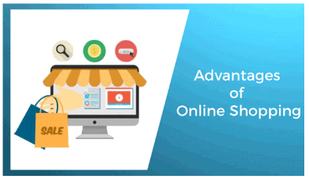
Figure1.2.2. Advantages of Online Shopping.
So let's see the reasons that many people love online shopping and the popularity behind it. The benefits of online shopping are discussed as follows -
Convenience
It is the major benefit of online shopping. Customers can purchase from their homes, workplaces as per their comfort. It is easy to cancel the transactions in online shopping. Online shopping made shopping easy as there are no lines to wait so that we can do shopping in minutes. We have the 24x7 opportunity to shop online. Online shopping saves time and effort. In online shopping, we can get detailed information about a product and get good discounts and lower prices.
No Crowds
During festivals, weekends, or holidays it is common to see the crowd at shopping places; it will be a huge headache and hectic to purchase products in this type of environment. But in online shopping, we do not have to face crowds, and also, we do not have any need to do unusual battles for parking.
No Pressure
Sometimes, shopkeepers pressurize us or use their skills to convince us to purchase things that we don't require. As a result, we purchase those things that we actually do not require. But in online shopping, we don't have any pressure to purchase unnecessary things.
Saves time
In online shopping, customers don't require to stand in queues to pay the price of products that they have been purchased. Online shopping provides the facility to shop from their office or home, so it saves traveling time. It also facilitates us to look for the products by entering some keywords or by using the search engines.
Saves Money
Marketers or e-tailers offer discounts to the customers in order to attract them to shop online. Retailers can sell the products with attractive discounts through online because of the removal of maintenance, real-estate cost.
Reviews of product
Most consumers read online reviews of a product to take basic information written by customers who already used it. Online reviews help to get the inside information of the product in which we are interested. For instance, if we are going to purchase cloth, we can see the reviews of that product; we will find some customers also add photos of themselves wearing that product. Hence we can do smart shopping. Reviews enable smart purchasing decisions for future customers and make them empowered.
Multiple varieties
It is one of the best advantages of online shopping. In online shopping, the buyer has multiple options and multiple brands to choose and from at a single place. There is a large volume of stock is available online.
We can find an item or any brand online and can get the latest international trends without spending money on airfare. We can purchase the desired products from the retailers whether they are in other parts of the state, country, or even world.
We can send gifts easily
Services of online shopping enable us to send surprise gifts to our friends and relatives. The gift will be packed and shipped by online vendors to the address we have entered. They will even pack the gift. So, no need to make an excuse of long-distance for not sending a gift on occasions like birthdays, weddings, anniversaries, and others.
Easy price comparison
In online shopping, it is easy to compare and research products and their prices. On shopping for appliances, we can find reviews, product comparisons, and compare the prices with the options available on the market.
Online tracking
In online shopping, consumers are facilitated with online tracking as they can easily track the order and delivery status. Along with the above benefits of online shopping, it has some limitations too. Now, let's see the limitations of online shopping.

1.3 Types and examples of Online shops in global market.
As of today, a large number of people are reliant on online shopping for their needs. The wave started off in America and slowly gained inkling around the world. As of today, it is slowly spreading in 3rd world countries such as India and China. It is bound to create ruffles to a point where it will silence everyone and slowly become a habit.
The shops already think of online retails as a threat to their business. Where this war is going to go; only time will tell! However, as far as the consumer is concerned, it becomes difficult for him to make a choice. Here are the top 10 online shopping sites in world 2022that will help you out.
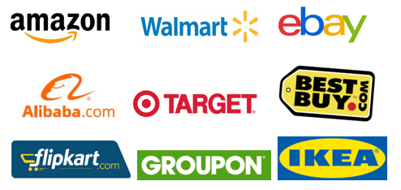
Figure 1.3.1 The Top of online store companies
Amazon.com is an American multinational technology company which focuses on e-commerce, cloud computing, digital streaming, and artificial intelligence. It has been referred to as "one of the most influential economic and cultural forces in the world", and is one of the world's most valuable brands. It is one of the Big Five American information technology companies, alongside Alphabet, Apple, Meta, and Microsoft.
Amazon was founded by Jeff Bezos from his garage in Bellevue, Washington, on July 5, 1994. Initially an online marketplace for books, it has expanded into a multitude of product categories: a strategy that has earned it the moniker The Everything Store. It has multiple subsidiaries including Amazon Web Services (cloud computing), Zoox (autonomous vehicles), Kuiper Systems (satellite Internet), Amazon Lab126 (computer hardware R&D). Its other subsidiaries include Ring, Twitch, IMDb, and Whole Foods Market. Its acquisition of Whole Foods in August 2017 for US$13.4 billion substantially increased its footprint as a physical retailer.
Amazon has earned a reputation as a disruptor of well-established industries through technological innovation and mass scale. As of 2021, it is the world's largest online retailer and marketplace, smart speaker provider, cloud computing service through AWS, live-streaming service through Twitch, and Internet company as measured by revenue and market share. In 2021, it surpassed Walmart as the world's largest retailer outside of China, driven in large part by its paid subscription plan, Amazon Prime, which has over 200 million subscribers worldwide. It is the second-largest private employer in the United States
Walmart is an American multinational retail corporation that operates a chain of hypermarkets (also called supercenters), discount department stores, and grocery stores from the United States, headquartered in Bentonville, Arkansas. The company was founded by Sam Walton in nearby Rogers, Arkansas in 1962 and incorporated under Delaware General Corporation Law on October 31, 1969. It also owns and operates Sam's Club retail warehouses.
As of April 30, 2022, Walmart has 10,585 stores and clubs in 24 countries, operating under 46 different names. The company operates under the name Walmart in the United States and Canada, as Walmart de México y Centroamérica in Mexico and Central America, and as Flipkart Wholesale in India. It has wholly owned operations in Chile, Canada, and South Africa. Since August 2018, Walmart held only a minority stake in Walmart Brasil, which was renamed Grupo Big in August 2019, with 20 percent of the company's shares, and private equity firm Advent International holding 80 percent ownership of the company. They, eventually, divested their shareholdings in Grupo Big to French retailer Carrefour, in transaction worth R$7 billion and completed on June 7, 2022.
Walmart is the world's largest company by revenue, with about US$570 billion in annual revenue, according to the Fortune Global 500 list in May 2022. It is also the largest private employer in the world with 2.2 million employees. It is a publicly traded family-owned business, as the company is controlled by the Walton family. Sam Walton's heirs own over 50 percent of Walmart through both their holding company Walton Enterprises and their individual holdings.[14] Walmart was the largest United States grocery retailer in 2019, and 65 percent of Walmart's US$510.329 billion sales came from U.S. operations.
Walmart was listed on the New York Stock Exchange in 1972. By 1988, it was the most profitable retailer in the U.S., and it had become the largest in terms of revenue by October 1989. The company was originally geographically limited to the South and lower Midwest, but it had stores from coast to coast by the early 1990s. Sam's Club opened in New Jersey in November 1989, and the first California outlet opened in Lancaster, in July 1990. A Walmart in York, Pennsylvania, opened in October 1990, the first main store in the Northeast.
eBay is an American multinational e-commerce company based in San Jose, California, that facilitates consumer-to-consumer and business-to-consumer sales through its website. eBay was founded by Pierre Omidyar in 1995, and became a notable success story of the dot-com bubble. eBay is a multibillion-dollar business with operations in about 32 countries, as of 2019. The company manages the eBay website, an online auction and shopping website in which people and businesses buy and sell a wide variety of goods and services worldwide. The website is free to use for buyers, but sellers are charged fees for listing items after a limited number of free listings, and an additional or separate fee when those items are sold.
In addition to eBay's original auction-style sales, the website has evolved and expanded to include: instant "Buy It Now" shopping; shopping by Universal Product Code, ISBN, or other kind of SKU number (via Half.com, which was shut down in 2017); and other services. eBay previously offered online money transfers as part of its services (via PayPal, which was a wholly owned subsidiary of eBay from 2002 to 2015); online classified advertisements (via Kijiji, or eBay Classifieds Group); and online event ticket trading
Alibaba Group Holding Limited, also known as Alibaba, is a Chinese multinational technology company specializing in e-commerce, retail, Internet, and technology. Founded on 28 June 1999 in Hangzhou, Zhejiang, the company provides consumer-to-consumer (C2C), business-to-consumer (B2C), and business-to-business (B2B) sales services via web portals, as well as electronic payment services, shopping search engines and cloud computing services. It owns and operates a diverse portfolio of companies around the world in numerous business sectors.
On 19 September 2014, Alibaba's initial public offering (IPO) on New York Stock Exchange raised US$25 billion, giving the company a market value of US$231 billion and, by far, then the largest IPO in world history. It is one of the top 10 most valuable corporations, and is named the 31st-largest public company in the world on the Forbes Global 2000 2020 list. In January 2018, Alibaba became the second Asian company to break the US$500 billion valuation mark, after its competitor Tencent. As of 2020, Alibaba has the sixth-highest global brand valuation.
Alibaba is one of the world's largest retailers and e-commerce companies. In 2020, it was also rated as the fifth-largest artificial intelligence company. It is also one of the biggest venture capital firms, and one of the biggest investment corporations in the world. The company hosts the largest B2B (Alibaba.com), C2C (Taobao), and B2C (Tmall) marketplaces in the world. It has been expanding into the media industry, with revenues rising by triple percentage points year after year. It also set the record on the 2018 edition of China's Singles' Day, the world's biggest online and offline shopping day.
Target Corporation (doing business as Target and stylized as target) is an American big box department store chain headquartered in Minneapolis, Minnesota. It is the eighth largest retailer in the United States, and a component of the S&P 500 Index. Target was established as the discount division of Dayton's department store of Minneapolis in 1962. It began expanding the store nationwide in the 1980s (as part of the Dayton-Hudson Corporation), and introduced new store formats under the Target brand in the 1990s. The company has found success as a cheap-chic player in the industry. The parent company was renamed Target Corporation in 2000, and divested itself of its last department store chains in 2004. It suffered from a massive, highly publicized security breach of customer credit card data and the failure of its short-lived Target Canada subsidiary in the early 2010s, but experienced revitalized success with its expansion in urban markets within the United States.
As of 2019, Target operates 1,931 stores throughout the United States, and is ranked number 37 on the 2020 Fortune 500 list of the largest U.S. corporations by total revenue. Their retail formats include the discount store Target, the hypermarket SuperTarget, and "small-format" stores previously named CityTarget and TargetExpress before being consolidated under the Target branding.

CHAPTER 2. PROGRAMMING LANGUAGES AND TOOLS

2.1 PHP programming language
PHP is an open-source server-side scripting language that many devs use for web development. It is also a general-purpose language that you can use to make lots of projects, including Graphical User Interfaces (GUIs).

What Does PHP Mean?
The abbreviation PHP initially stood for Personal Homepage. But now it is a recursive acronym for Hypertext Preprocessor. (It's recursive in the sense that the first word itself is an abbreviation, so the full meaning doesn't follow the abbreviation.)
The first version of PHP was launched 26 years ago. Now it's on version 8, released in November 2020, but version 7 remains the most widely used.
PHP runs on the Zend engine, which is the most popular implementation. There are some other implementations as well, like parrot, HPVM (Hip Hop Virtual Machine), and Hip Hop, created by Facebook.
PHP is mostly used for making web servers. It runs on the browser and is also capable of running in the command line. So, if you don't feel like showing your code output in the browser, you can show it in the terminal.
Advantages of PHP
- PHP has some advantages that have made it so popular, and it's been the go-to language for web servers for more than 15 years now. Here are some of PHP's benefits:
- Cross-Platform: PHP is platform-independent. You don't have to have a particular OS to use it because it runs on every platform, whether it's Mac, Windows, or Linux.
- Open Source: PHP is open source. The original code is made available to everyone who wants to build upon it. This is one of the reasons why one of its frameworks, Laravel, is so popular.
- Easy to learn: PHP is not hard to learn for absolute beginners. You can pick it up pretty if you already have programming knowledge.
- PHP syncs with all Databases: You can easily connect PHP to all Databases, relational and non-relational. So it can connect in no time to MySQL, Postgress, MongoDB, or any other database.
- Supportive Community: PHP has a very supportive online community. The official documentation provides guides on how to use the features and you can easily get your problem fixed while stuck.

2.2 content management systems(CMS)
What Is a Content Management System (CMS)?
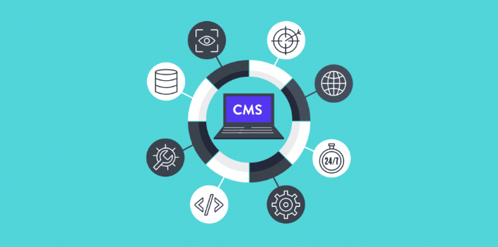
Figure 2.2.1. Content Management System.
A content management system, often abbreviated as CMS, is software that helps users create, manage, and modify content on a website without the need for specialized technical knowledge.
In simpler language, a content management system is a tool that helps you build a website without needing to write all the code from scratch (or even know how to code at all).
Instead of building your own system for creating web pages, storing images, and other functions, the content management system handles all that basic infrastructure stuff for you so that you can focus on more forward-facing parts of your website.
How Does a Content Management System Work?
To give you an idea of how a content management system works, we’re going to take a whirlwind tour of the WordPress interface (WordPress is a good example of a content management system).
Let’s start with creating a piece of content. Without a content management system, you’d need to write a static HTML file and upload it to your server (sounds complicated, right?).
With a content management system like WordPress, you can just write your content in an interface that looks a good bit like Microsoft Word:
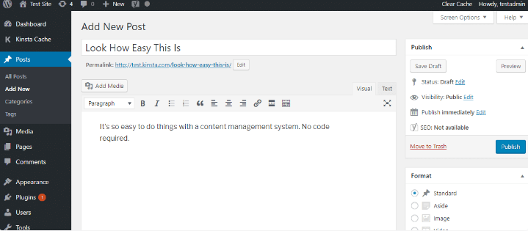
Figure 2.2.2 Access to CMS
What Makes up a Content Management System?
On a more technical level, a content management system is made up of two core parts:
- A content management application (CMA) – this is the part that allows you to actually add and manage content on your site (like you saw above).
- A content delivery application (CDA) – this is the backend, behind-the-scenes process that takes the content you input in the CMA, stores it properly, and makes it visible to your visitors.
What Kinds of Websites Can You Build with Those Content Management Systems?
Most content management systems are pretty flexible nowadays. While there are some that focus on a specific use – like Magento and eCommerce – most of the popular content management systems can be used to create essentially any type of website.
For example, you can use WordPress to power:
- Static websites
- Blogs
- eCommerce stores
- Forums
- Social networks
- Online courses
- Membership sites
- Portfolios
- Etc.
What Is the Best CMS Platform?
This is a little bit like asking, “what is the best flavor of ice cream?”.
Sure, everyone’s got their answer, but it’s difficult to come up with a factual argument for one content management system being the best in 100% of situations.
What we can do, though, is return to the numbers and make a suggestion that there’s a reason WordPress has such a dominant share of the content management system market:
- For most types of websites, it provides the most user-friendly, flexible solution. It’s not always the best option, but it is the best option most of the time.
- For a deeper comparison of some of the popular content management systems, you can view our posts on:
- WordPress vs Drupal
- WordPress vs Squarespace
- How to Build a Website with a Content Management System
- Want to build your own website with a content management system? If so, the general process looks something like this:
- Purchase web hosting and a domain name
- Install your content management system of choice on your web server
- Configure the content management system to dictate how your site looks and functions
- Start writing content using the content management system’s interface
- It’s actually surprisingly simple. And hosts like Kinsta can even help install the content management system for you (WordPress, in this case), so you can jump straight into building your site without any technical setup.
- A content management system (CMS) is an application that helps you create and manage a website via a human-friendly interface rather than needing to work directly with code.
- Over the rest of this post, we’ll dig into the question of “what is a content management system” with a more detailed CMS definition and share some examples of the most popular content management systems.
An official CMS definition
CMS definitions vary in their descriptions, but the consensus brings us to this definition:
Content management system (CMS) noun: a digital application for managing content and letting multiple users create, format, edit, and publish content, usually on the internet, stored in a database, and presented in some form, like with a website. Although an official CMS definition like that seems rigid, it actually helps cover the broadness of the content management system market, seeing as how so many of them vary in features.
How does a content management system work?
From that CMS definition, all content management systems:
- Are digital. They’re applications used on computers, sometimes offline, but more frequently online.
- Help users create, format, edit, and publish content. This may include support for media, written content, or drop quotes based on the CMS, but the core idea is that you can make and publish some sort of content.
- Store the content in a database. Again, the supported database and hosting types vary from CMS to CMS, but the content always gets logged inside a database.
- Give access to multiple users. One CMS may have unique user permissions, while another might allow for specific editor, author, and admin roles.
Present the content. As mentioned, this usually happens on the frontend of a live website, but some content management systems allow for private or even offline publication.
What to look for in a CMS?
When conducting your research on content management systems, we recommend looking for the following features:
- A powerful content editor with both visual and code-based editing options. It’s also nice to see drag-and-drop builders.
- Core CMS functionality like the ability to add, format, and publish content, while also incorporating user roles.
- Access to third-party themes, plugins, and integrations for improving your site.
- CMS marketing features or integrations for things like email marketing, social media, and coupons.
- Ecommerce capabilities to potentially sell products.
- Flexibility with your design. This includes mobile responsiveness and custom code control.
Structure
A CMS typically has two major components: a content management application (CMA), as the front-end user interface that allows a user, even with limited expertise, to add, modify, and remove content from a website without the intervention of a webmaster; and a content delivery application (CDA), that compiles the content and updates the website.
Installation type
There are two types of CMS installation: on-premises and cloud-based. On-premises installation means that the CMS software can be installed on the server. This approach is usually taken by businesses that want flexibility in their setup. Notable CMSs which can be installed on-premises are Wordpress.org, Drupal, Joomla, ModX and others.
The cloud-based CMS is hosted on the vendor environment. With this approach the CMS software cannot be modified for the customer. Examples of notable cloud-based CMSs are SquareSpace, Wordpress.com, and WIX.
Common features
The core CMS features are: indexing, search and retrieval, format management, revision control, and management.[5]
Features may vary depending on the system application but will typically include:
- Intuitive indexing, search and retrieval features index all data for easy access through search functions and allow users to search by attributes such as publication dates, keywords or author.
- Format management facilitates turning scanned paper documents and legacy electronic documents into HTML or PDF documents.
- Revision features allow content to be updated and edited after initial publication. Revision control also tracks any changes made to files by individuals.
- Publishing functionality allows individuals to use a template or a set of templates approved by the organization, as well as wizards and other tools to create or modify content.
Popular additional features may include:
- SEO-friendly URLs
- Integrated and online help, including discussion boards
- Group-based permission systems
- Full template support and customizable templates
- Easy wizard-based install and versioning procedures
- Admin panel with multiple language support
- Content hierarchy with unlimited depth and size
- Minimal server requirements
- Integrated file managers
- Integrated audit logs
- Support AMP page for Google
- Support schema markup
- Designed as per Google quality guidelines for website architecture
Other types of content management systems
Digital asset management systems are another type of CMS. They manage content with clearly defined author or ownership, such as documents, movies, pictures, phone numbers, and scientific data. Companies also use CMSs to store, control, revise, and publish documentation.
There are also component content management systems (CCMS), which are CMSs that manage content at a modular level rather than as pages or articles. CCMSs are often used in technical communication where many publications reuse the same content.
2.3 Database Management System and MySQL
Database management system (DBMS)
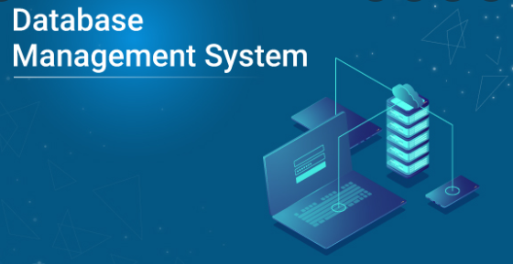
Figure 2.3.1 Database management system.
A database management system (or DBMS) is essentially nothing more than a computerized data-keeping system. Users of the system are given facilities to perform several kinds of operations on such a system for either manipulation of the data in the database or the management of the database structure itself. Database Management Systems (DBMSs) are categorized according to their data structures or types.
There are several types of databases that can be used on a mainframe to exploit inverted list, hierarchic, network, or relational.
Mainframe sites tend to use a hierarchical model when the data structure (not data values) of the data needed for an application is relatively static. For example, a Bill of Material (BOM) database structure always has a high level assembly part number, and several levels of components with subcomponents. The structure usually has a component forecast, cost, and pricing data, and so on. The structure of the data for a BOM application rarely changes, and new data elements (not values) are rarely identified. An application normally starts at the top with the assembly part number, and goes down to the detail components.
Hierarchical and relational database systems have common benefits. RDBMS has the additional, significant advantage over the hierarchical DB of being non-navigational. By navigational, we mean that in a hierarchical database, the application programmer must know the structure of the database. The program must contain specific logic to navigate from the root segment to the desired child segments containing the desired attributes or elements. The program must still access the intervening segments, even though they are not needed.
What structures exist in a relational database?
Relational databases include the following structures:
Database
A database is a logical grouping of data. It contains a set of related table spaces and index spaces. Typically, a database contains all the data that is associated with one application or with a group of related applications. You could have a payroll database or an inventory database, for example.
Table
A table is a logical structure made up of rows and columns. Rows have no fixed order, so if you retrieve data you might need to sort the data. The order of the columns is the order specified when the table was created by the database administrator. At the intersection of every column and row is a specific data item called a value, or, more precisely, an atomic value. A table is named with a high-level qualifier of the owner's user ID followed by the table name, for example TEST.DEPT or PROD.DEPT. There are three types of tables:
- A base table that is created and holds persistent data
- A temporary table that stores intermediate query results
- A results table that is returned when you query tables.

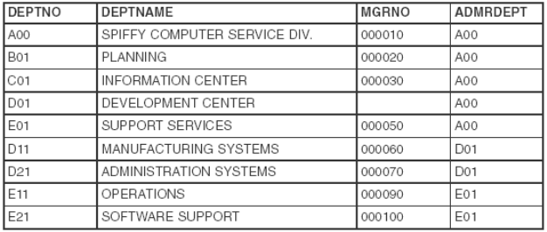
Figure 2.3.2 Example of a DB2 table (department table)
In this table we use:
- Columns–The ordered set of columns are DEPTNO, DEPTNAME, MGRNO, and ADMRDEPT. All the data in a given column must be of the same data type.
- Rows–Each row contains data for a single department.
- Values–At the intersection of a column and row is a value. For example, PLANNING is the value of the DEPTNAME column in the row for department B01.
Indexes
An index is an ordered set of pointers to rows of a table. Unlike the rows of a table that are not in a specific order, an index must always be maintained in order by DB2. An index is used for two purposes:
- For performance, to retrieve data values more quickly
- For uniqueness.
By creating an index on an employee's name, you can retrieve data more quickly for that employee than by scanning the entire table. Also, by creating a unique index on an employee number, DB2 will enforce the uniqueness of each value. A unique index is the only way DB2 can enforce uniqueness.
Creating an index automatically creates the index space, the data set that contains the index.
Keys
A key is one or more columns that are identified as such in the creation of a table or index, or in the definition of referential integrity.
Primary key
A table can only have one primary key because it defines the entity. There are two requirements for a primary key:
- It must have a value, that is, it cannot be null.
- It must be unique, that is, it must have a unique index defined on it.
Unique key
We already know that a primary key must be unique, but it is possible to have more than one unique key in a table. In our EMP table example, the employee number is defined as the primary key and is therefore unique. If we also had a social security value in our table, hopefully that value would be unique. To guarantee this, you could create a unique index on the social security column.
Foreign key
A foreign key is a key that is specified in a referential integrity constraint to make its existence dependent on a primary or unique key (parent key) in another table.
The example given is that of an employee's work department number relating to the primary key defined on the department number in the DEPT table. This constraint is part of the definition of the table.
MySQL
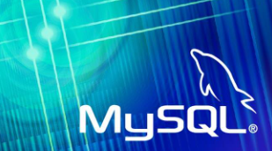
Figure 2.3.3 MySQL
What is MySQL?
MySQL, the most popular Open Source SQL database management system, is developed, distributed, and supported by Oracle Corporation.
- MySQL is a database management system.
A database is a structured collection of data. It may be anything from a simple shopping list to a picture gallery or the vast amounts of information in a corporate network. To add, access, and process data stored in a computer database, you need a database management system such as MySQL Server. Since computers are very good at handling large amounts of data, database management systems play a central role in computing, as standalone utilities, or as parts of other applications.
- MySQL databases are relational.
A relational database stores data in separate tables rather than putting all the data in one big storeroom. The database structures are organized into physical files optimized for speed. The logical model, with objects such as databases, tables, views, rows, and columns, offers a flexible programming environment. You set up rules governing the relationships between different data fields, such as one-to-one, one-to-many, unique, required or optional, and “pointers” between different tables. The database enforces these rules, so that with a well-designed database, your application never sees inconsistent, duplicate, orphan, out-of-date, or missing data. The SQL part of “MySQL” stands for “Structured Query Language”. SQL is the most common standardized language used to access databases. Depending on your programming environment, you might enter SQL directly (for example, to generate reports), embed SQL statements into code written in another language, or use a language-specific API that hides the SQL syntax. SQL is defined by the ANSI/ISO SQL Standard. The SQL standard has been evolving since 1986 and several versions exist. In this manual, “SQL-92” refers to the standard released in 1992, “SQL:1999” refers to the standard released in 1999, and “SQL:2003” refers to the current version of the standard. We use the phrase “the SQL standard” to mean the current version of the SQL Standard at any time.
The MySQL Database Server is very fast, reliable, scalable, and easy to use.
- If that is what you are looking for, you should give it a try. MySQL Server can run comfortably on a desktop or laptop, alongside your other applications, web servers, and so on, requiring little or no attention. If you dedicate an entire machine to MySQL, you can adjust the settings to take advantage of all the memory, CPU power, and I/O capacity available. MySQL can also scale up to clusters of machines, networked together.
- MySQL Server was originally developed to handle large databases much faster than existing solutions and has been successfully used in highly demanding production environments for several years. Although under constant development, MySQL Server today offers a rich and useful set of functions. Its connectivity, speed, and security make MySQL Server highly suited for accessing databases on the Internet.
MySQL Server works in client/server or embedded systems.
- The MySQL Database Software is a client/server system that consists of a multithreaded SQL server that supports different back ends, several different client programs and libraries, administrative tools, and a wide range of application programming interfaces (APIs).
- We also provide MySQL Server as an embedded multithreaded library that you can link into your application to get a smaller, faster, easier-to-manage standalone product.
2.4 HTML & CSS
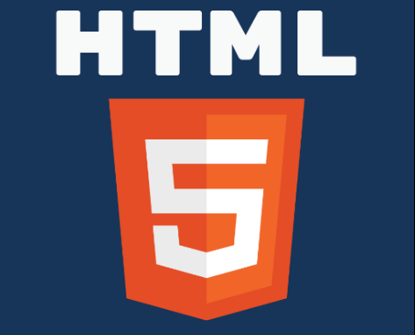
Figure 2.4.1 HTML (Hypertext Markup Language)
What Is HTML?
HTML (stands for Hypertext Markup Language) is a computer language that makes up most web pages and online applications. A hypertext is a text that is used to reference other pieces of text, while a markup language is a series of markings that tells web servers the style and structure of a document.
The average website includes several different HTML pages. For instance, a home page, an about page, and a contact page would all have separate HTML files.

- HTML documents are files that end with a .html or .htm extension. A web browser reads the HTML file and renders its content so that internet users can view it.
- All HTML pages have a series of HTML elements, consisting of a set of tags and attributes. HTML elements are the building blocks of a web page. A tag tells the web browser where an element begins and ends, whereas an attribute describes the characteristics of an element.
The three main parts of an element are:
Opening tag – used to state where an element starts to take effect. The tag is wrapped with opening and closing angle brackets. For example, use the start tag <p> to create a paragraph.
Content – this is the output that other users see.
Closing tag – the same as the opening tag, but with a forward slash before the element name. For example, </p> to end a paragraph.
The combination of these three parts will create an HTML element:
Another critical part of an HTML element is its attribute, which has two sections – a name and attribute value. The name identifies the additional information that a user wants to add, while the attribute value gives further specifications.
For example, a style element adding the color purple and the font-family verdana will look like this:
Another attribute, the HTML class, is most important for development and programming. The class attribute adds style information that can work on different elements with the same class value.
For example, we will use the same style for a heading <h1> and a paragraph <p>. The style includes background color, text color, border, margin, and padding, under the class .important. To achieve the same style between <h1> and <p>, add class=”important” after each start tag:
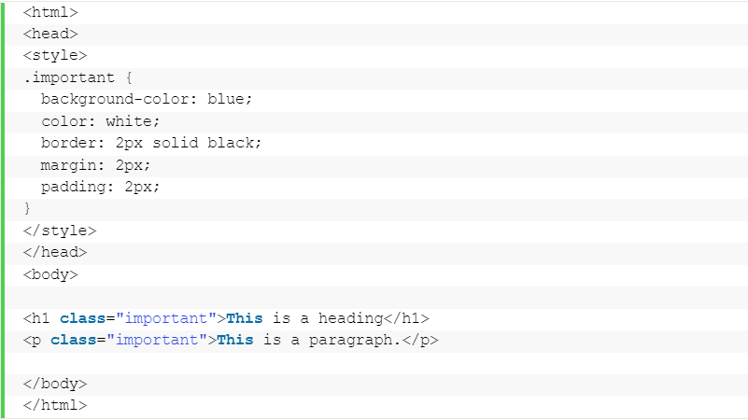
Most elements have an opening and a closing tag, but some elements do not need closing tags to work, such as empty elements. These elements do not use an end tag because they do not have content:
This image tag has two attributes – an src attribute, the image path, and an alt attribute, the descriptive text. However, it does not have content nor an end tag.
Lastly, every HTML document must start with a <!DOCTYPE> declaration to inform the web browser about the document type. With HTML5, the doctype HTML public declaration will be:

CSS.
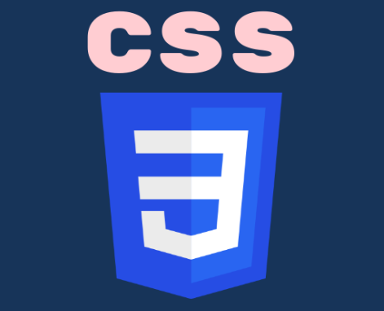
Figure 2.4.2 CSS (Cascading Style Sheet) language
What Is CSS?
CSS is what’s called a Cascading Style Sheet language, and is used to stylize elements written in a markup language such as HTML. It separates the content from the visual representation of the site.
CSS Advantages
The difference between a website which implements CSS and one that doesn’t is massive and surely noticeable.
You might have seen a website that fails to load completely and has a white background with most of the text being blue and black. This means that the CSS part of the site didn’t load correctly or it doesn’t exist altogether.
That’s how a site with only HTML looks like, and I think you’d agree that that’s not very appealing.
Before using CSS, all of the stylizing had to be included into the HTML markup. This means you had to separately describe all the background, font colors, alignments, etc.
CSS lets you stylize everything on a different file, thus creating the style there and later on integrating the CSS file on top of the HTML markup. This makes the actual HTML markup much cleaner and easier to maintain. In short, with CSS you don’t need to repeatedly describe how individual elements look. This saves time, shortens the code and makes it not as prone to errors.
CSS lets you have multiple styles on one HTML page, therefore making the customization possibilities almost endless. Nowadays, this is becoming more a necessity than a commodity.
How CSS Works
CSS uses a simple English based syntax with a set of rules that govern it. Like we’ve mentioned before, HTML was never intended to use style elements, only the markup of the page. It was created to merely describe the content. For example: <p>This is a paragraph.</p>. But how do you style the paragraph? The CSS syntax structure is pretty simple. It has a selector and a declaration block. You select an element and then declare what you want to do with it. Pretty straightforward, right? However, there are rules you have to remember. The structure rules are pretty simple, so don’t worry.
The selector points to the HTML element you want to style. The declaration block contains one or more declarations separated by semicolons. Each declaration includes a CSS property name and a value, separated by a colon. A CSS declaration always ends with a semicolon, and declaration blocks are surrounded by curly braces.
Let’s look at an example:
All of the <p> elements will be colored blue and bolded.
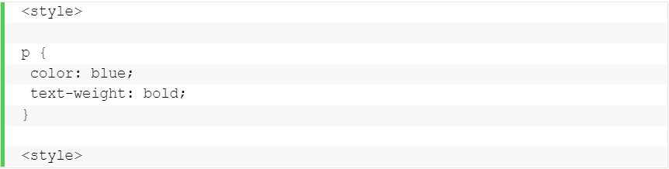
In another example, all <p> elements will be center-aligned, be 16x wide and pink.
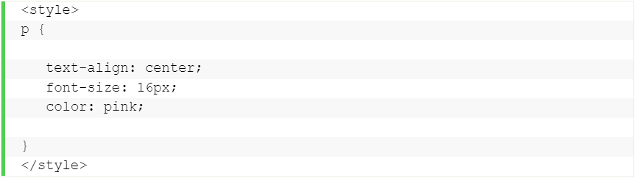
Internal, External and Inline CSS Styles
We’ll go over each style briefly, for an in-depth explanation of each method, there will be a link below the overview.
Let’s start by talking about the Internal style. CSS styles done this way are loaded each time a website is refreshed, which may increase loading time. Additionally, you won’t be able to use the same CSS style on multiple pages as it’s contained within a single page. However, this also comes with benefits. Having everything on one page makes it easier to share the template for a preview.
The External method might be the most convenient one. Everything is done externally on a .css file. This means you can do all the styling on a separate file and apply the CSS to any page you want. The External style might also improve loading times.
Lastly, we will talk about the Inline style of CSS. Inline works with specific elements that have the <style> tag. Each component has to be stylized, so it might not be the best or fastest way to handle CSS. But it can come in handy. For example, if you want to change a single element, quickly preview changes, or maybe you don’t have access to the CSS files.

CHAPTER 3. SDD ONLINE STORE

3.1 Describe and showcase of online store
About System
Talking about the features of this system, the admin can manage the users, products, and check subscribers. While the user can shop for all the available shopping items by signing in. And, in order to buy products online, he/she has to sign up/in through the system.
The user can shop for multiple items and pay online through cards. This simple project is similar to the online shop portal. The design of this project is very simple so that the user won’t find any difficulties while working on it.
This project is developed using PHP, CSS, JavaScript, and MySQL as the database used. This project contains the admin side and user side where a user can view shopping items details, sign up, and buy products online. While the admin can add items and users, products, manage them, and soon. The admin can manage the users, products, and check subscribers while the user can shop for all the available shopping items by signing in. And, to buy products online, he/she has to sign up/in through the system. The user can shop for multiple items and pay online through virtual credit cards. This simple project is similar to the online shop portal. The design of this project is effortless so that the user won’t find any difficulties while working on it. This system is only used for educational purposes only.
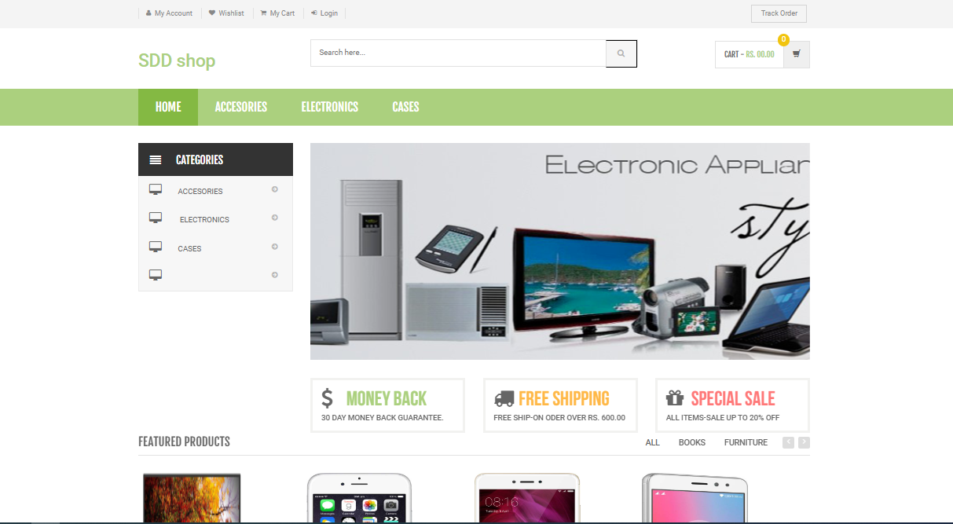
Figure 3.1.1 Main menu
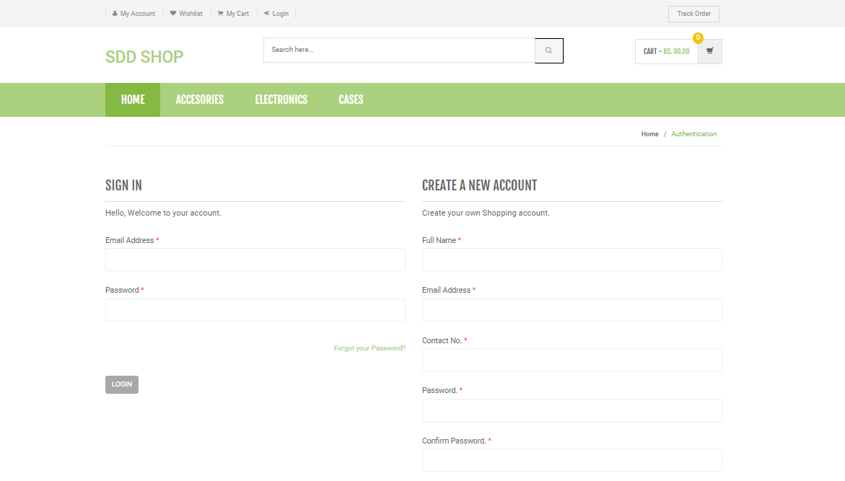
Figure 3.1.2 login to shop

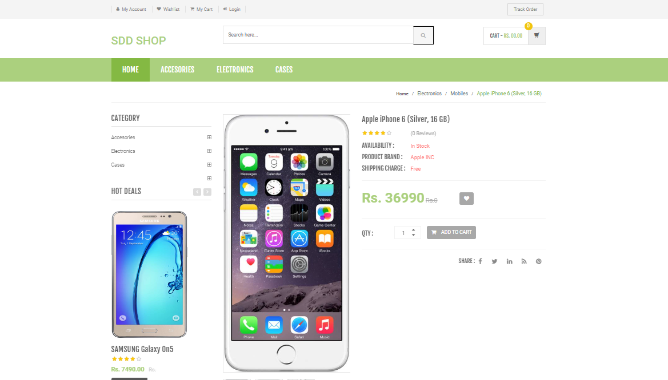
Figure 3.1.3. Selected product
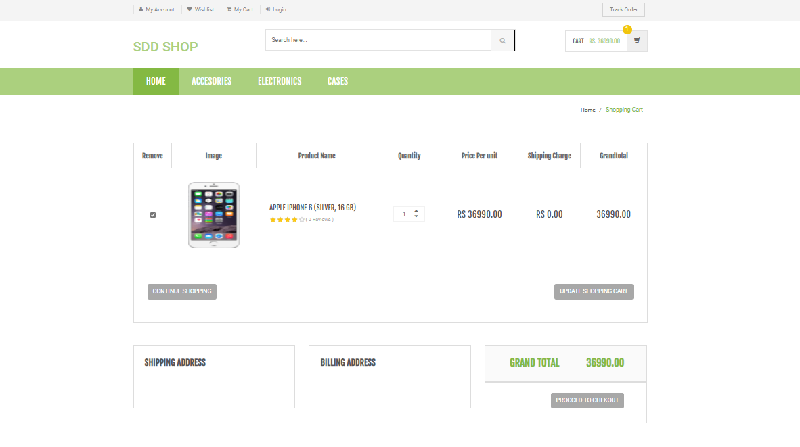
Figure 3.1.4. Basket
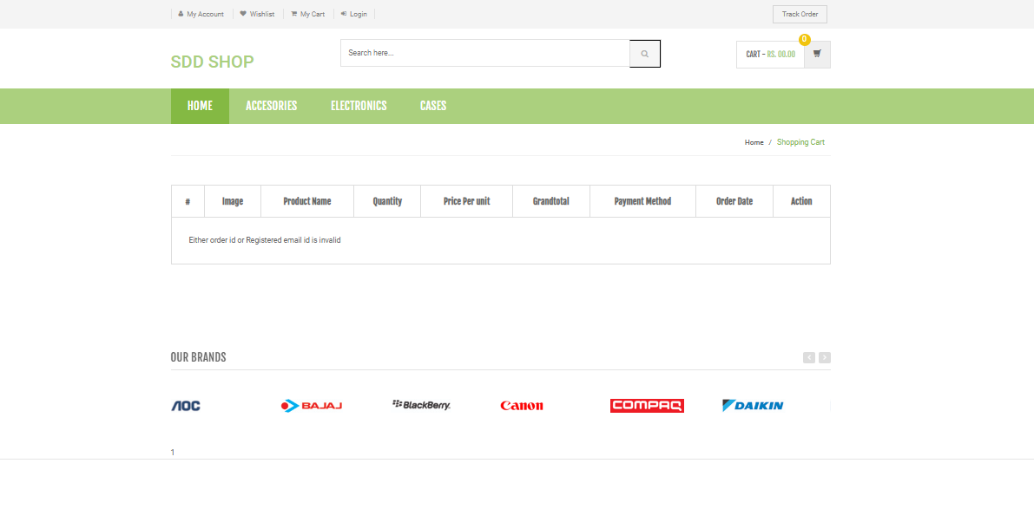
Figure 3.1.5. Paying for a product

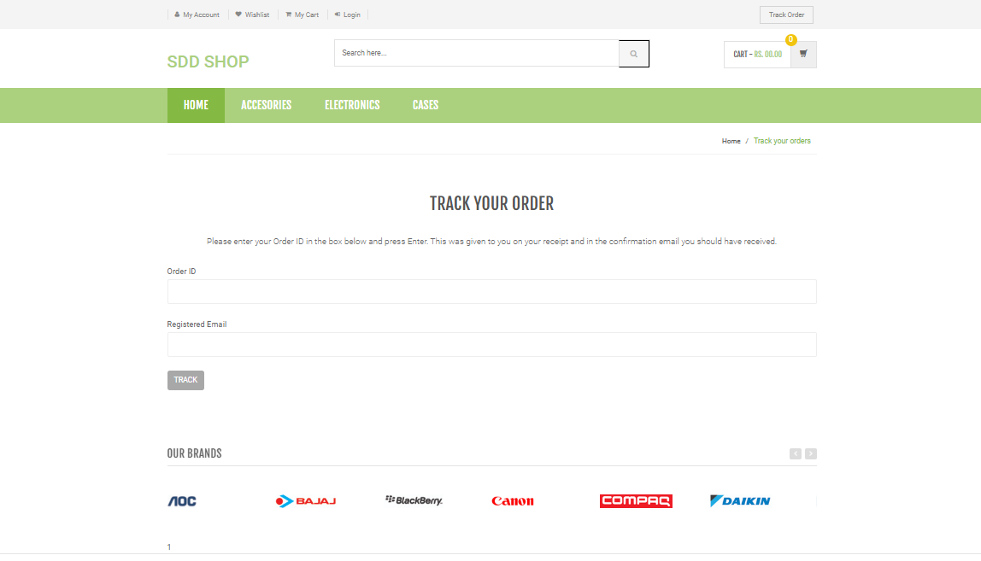
Figure 3.1.6. Delivery part

3.2 About database management system and design
What is Database Design?
Database Design is a collection of processes that facilitate the designing, development, implementation and maintenance of enterprise data management systems. Properly designed database are easy to maintain, improves data consistency and are cost effective in terms of disk storage space. The database designer decides how the data elements correlate and what data must be stored.
The main objectives of database design in DBMS are to produce logical and physical designs models of the proposed database system. The logical model concentrates on the data requirements and the data to be stored independent of physical considerations. It does not concern itself with how the data will be stored or where it will be stored physically. The physical data design model involves translating the logical DB design of the database onto physical media using hardware resources and software systems such as database management systems (DBMS).
Why Database Design is Important ?
It helps produce database systems
- That meet the requirements of the users
- Have high performance.
Database design process in DBMS is crucial for high performance database system.
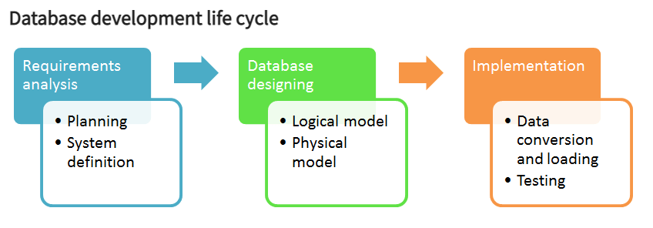
Figure 3.2.1. Database development life cycle.
The database development life cycle has a number of stages that are followed when developing database systems.
The steps in the development life cycle do not necessarily have to be followed religiously in a sequential manner.
On small database systems, the process of database design is usually very simple and does not involve a lot of steps.
In order to fully appreciate the above diagram, let’s look at the individual components listed in each step for overview of design process in DBMS.
Database designing
- Logical model – This stage is concerned with developing a database model based on requirements. The entire design is on paper without any physical implementations or specific DBMS considerations.
- Physical model – This stage implements the logical model of the database taking into account the DBMS and physical implementation factors.
Implementation
- Data conversion and loading – this stage of relational databases design is concerned with importing and converting data from the old system into the new database.
- Testing – this stage is concerned with the identification of errors in the newly implemented system. It checks the database against requirement specifications.
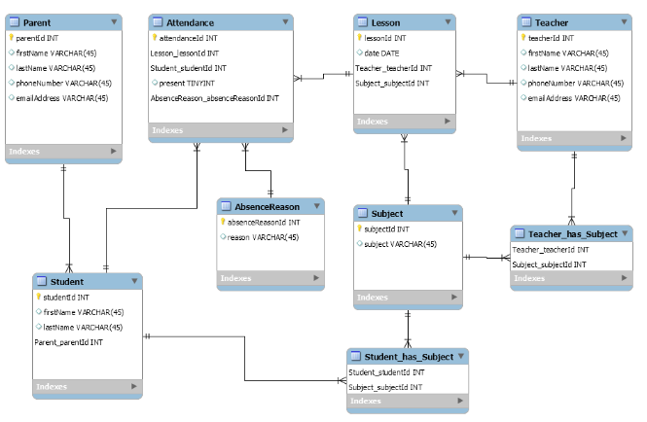
Figure 3.2.2. Graphical view of database design
A Database Management System (DBMS) is a software system designed to efficiently store, retrieve, manipulate, and query large amounts of data. Since the introduction of the relational data model in 1970, the database management system industry has grown to $100 billion dollars a year and increases by more that 25% every year. With the new and emerging internet applications posing new requirements in the DBMS design and implementation, the database market is expected to grow even faster, and database design and implementation techniques are constantly evolving to meet the new requirements.
Nevertheless, there is a basic and fairly standard set of techniques that have been developed to support high-performance database systems. These techniques include: B+trees, hash-based join algorithms, hierarchical and two-phase locking, two-phase commit, write-ahead-logging, recovery using shadow pages, and several query optimization strategies. The synergy amongst different techniques often poses restrictions; the design and implementation choices made at a certain module of the system may affect its interaction with others, and can place constraints on decisions at other levels that may not be immediately apparent.
The goal of this course is to investigate the traditional techniques and their interactions by studying several seminal papers and survey studies in the area while building a complete, scaled-down, relational database management system. Because the focus of the course is on the design as well as the implementation of DBMSs an emphasis will be placed on a large, semester-long DBMS implementation project. This intensive project will count for a substantial portion of the grade.

CONCLUSION

This PHP-based online shopping project is a web-based application that can be used to sell and buy things by both entrepreneurs and customers. It may be accessed through internet services from any location. Most supermarkets and mini-markets in many major cities have adopted the online purchasing procedure since it is convenient, dependable, and quick.
Technology has advanced significantly in recent years to give consumers with a better online shopping experience, and it will continue to do so in the future.People have predicted that internet shopping may surpass in-store purchasing due to the rapid increase of items and brands. While this may be true in certain cases, there is still a demand for brick and mortar businesses in market locations where customers like to see and touch the products they are purchasing. The advent of internet purchasing, on the other hand, has resulted in a more knowledgeable customer who can browse around with relative ease and without wasting a lot of time. At the end, it has been a win-win situation for both consumer and sellers.

LIST OF USED LITERATURE

- Mowafa Househ, Andre W. Kushniruk, Elizabeth M. Borycki - Big Data, Big Challenges. 2019.
- Information Technology Essentials: Basic Foundations for Information Technology Professionals by Eric Frick.
- Information Technology and Mobile Communication by Das Thomas.
- Beginning Database Design Solutions - Rod Stephens.
- Wikipedia
- tutorialspoint
- w3schools
- php point
- researchgate

SOURCE CODE STRUCTURE AND DESCRIPTION
<?php
session_start();
error_reporting(0);
include('includes/config.php');
if(isset($_GET['action']) && $_GET['action']=="add"){
$id=intval($_GET['id']);
if(isset($_SESSION['cart'][$id])){
$_SESSION['cart'][$id]['quantity']++;
}else{
$sql_p="SELECT * FROM products WHERE id={$id}";
$query_p=mysqli_query($con,$sql_p);
if(mysqli_num_rows($query_p)!=0){
$row_p=mysqli_fetch_array($query_p);
$_SESSION['cart'][$row_p['id']]=array("quantity" => 1, "price" => $row_p['productPrice']);

}else{
$message="Product ID is invalid";
}
}
echo "<script>alert('Product has been added to the cart')</script>";
echo "<script type='text/javascript'> document.location ='my-cart.php'; </script>";
}

?>
<!DOCTYPE html>
<html lang="en">
<head>
<!-- Meta -->
<meta charset="utf-8">
<meta http-equiv="Content-Type" content="text/html; charset=UTF-8">
<meta name="viewport" content="width=device-width, initial-scale=1.0, user-scalable=no">
<meta name="description" content="">
<meta name="author" content="">
<meta name="keywords" content="MediaCenter, Template, eCommerce">
<meta name="robots" content="all">

<title>Shopping Portal Home Page</title>

<!-- Bootstrap Core CSS -->
<link rel="stylesheet" href="assets/css/bootstrap.min.css">

<!-- Customizable CSS -->
<link rel="stylesheet" href="assets/css/main.css">
<link rel="stylesheet" href="assets/css/green.css">
<link rel="stylesheet" href="assets/css/owl.carousel.css">
<link rel="stylesheet" href="assets/css/owl.transitions.css">
<!--<link rel="stylesheet" href="assets/css/owl.theme.css">-->
<link href="assets/css/lightbox.css" rel="stylesheet">
<link rel="stylesheet" href="assets/css/animate.min.css">
<link rel="stylesheet" href="assets/css/rateit.css">
<link rel="stylesheet" href="assets/css/bootstrap-select.min.css">

<!-- Demo Purpose Only. Should be removed in production -->
<link rel="stylesheet" href="assets/css/config.css">

<link href="assets/css/green.css" rel="alternate stylesheet" title="Green color">
<link href="assets/css/blue.css" rel="alternate stylesheet" title="Blue color">
<link href="assets/css/red.css" rel="alternate stylesheet" title="Red color">
<link href="assets/css/orange.css" rel="alternate stylesheet" title="Orange color">
<link href="assets/css/dark-green.css" rel="alternate stylesheet" title="Darkgreen color">
<link rel="stylesheet" href="assets/css/font-awesome.min.css">
<link href='http://fonts.googleapis.com/css?family=Roboto:300,400,500,700' rel='stylesheet' type='text/css'>

<!-- Favicon -->
<link rel="shortcut icon" href="assets/images/favicon.ico">

</head>
<body class="cnt-home">

<!-- ============================================== HEADER ============================================== -->
<header class="header-style-1">
<?php include('includes/top-header.php');?>
<?php include('includes/main-header.php');?>
<?php include('includes/menu-bar.php');?>
</header>

<!-- ============================================== HEADER : END ============================================== -->
<div class="body-content outer-top-xs" id="top-banner-and-menu">
<div class="container">
<div class="furniture-container homepage-container">
<div class="row">

<div class="col-xs-12 col-sm-12 col-md-3 sidebar">
<!-- ================================== TOP NAVIGATION ================================== -->
<?php include('includes/side-menu.php');?>
<!-- ================================== TOP NAVIGATION : END ================================== -->
</div><!-- /.sidemenu-holder -->

<div class="col-xs-12 col-sm-12 col-md-9 homebanner-holder">
<!-- ========================================== SECTION – HERO ========================================= -->

<div id="hero" class="homepage-slider3">
<div id="owl-main" class="owl-carousel owl-inner-nav owl-ui-sm">
<div class="full-width-slider">
<div class="item" style="background-image: url(assets/images/sliders/slider1.png);">
<!-- /.container-fluid -->
</div><!-- /.item -->
</div><!-- /.full-width-slider -->

<div class="full-width-slider">
<div class="item full-width-slider" style="background-image: url(assets/images/sliders/slider2.png);">
</div><!-- /.item -->
</div><!-- /.full-width-slider -->

</div><!-- /.owl-carousel -->
</div>

<!-- ========================================= SECTION – HERO : END ========================================= -->
<!-- ============================================== INFO BOXES ============================================== -->
<div class="info-boxes wow fadeInUp">
<div class="info-boxes-inner">
<div class="row">
<div class="col-md-6 col-sm-4 col-lg-4">
<div class="info-box">
<div class="row">
<div class="col-xs-2">
<i class="icon fa fa-dollar"></i>
</div>
<div class="col-xs-10">
<h4 class="info-box-heading green">money back</h4>
</div>
</div>
<h6 class="text">30 Day Money Back Guarantee.</h6>
</div>
</div><!-- .col -->

<div class="hidden-md col-sm-4 col-lg-4">
<div class="info-box">
<div class="row">
<div class="col-xs-2">
<i class="icon fa fa-truck"></i>
</div>
<div class="col-xs-10">
<h4 class="info-box-heading orange">free shipping</h4>
</div>
</div>
<h6 class="text">free ship-on oder over Rs. 600.00</h6>
</div>
</div><!-- .col -->

<div class="col-md-6 col-sm-4 col-lg-4">
<div class="info-box">
<div class="row">
<div class="col-xs-2">
<i class="icon fa fa-gift"></i>
</div>
<div class="col-xs-10">
<h4 class="info-box-heading red">Special Sale</h4>
</div>
</div>
<h6 class="text">All items-sale up to 20% off </h6>
</div>
</div><!-- .col -->
</div><!-- /.row -->
</div><!-- /.info-boxes-inner -->

</div><!-- /.info-boxes -->
<!-- ============================================== INFO BOXES : END ============================================== -->
</div><!-- /.homebanner-holder -->

</div><!-- /.row -->

<!-- ============================================== SCROLL TABS ============================================== -->
<div id="product-tabs-slider" class="scroll-tabs inner-bottom-vs wow fadeInUp">
<div class="more-info-tab clearfix">
<h3 class="new-product-title pull-left">Featured Products</h3>
<ul class="nav nav-tabs nav-tab-line pull-right" id="new-products-1">
<li class="active"><a href="#all" data-toggle="tab">All</a></li>
<li><a href="#books" data-toggle="tab">Books</a></li>
<li><a href="#furniture" data-toggle="tab">Furniture</a></li>
</ul><!-- /.nav-tabs -->
</div>

<div class="tab-content outer-top-xs">
<div class="tab-pane in active" id="all">
<div class="product-slider">
<div class="owl-carousel home-owl-carousel custom-carousel owl-theme" data-item="4">
<?php
$ret=mysqli_query($con,"select * from products");
while ($row=mysqli_fetch_array($ret))
{
# code...

?>

<div class="item item-carousel">
<div class="products">

<div class="product">
<div class="product-image">
<div class="image">
<a href="product-details.php?pid=<?php echo htmlentities($row['id']);?>">
<img src="admin/productimages/<?php echo htmlentities($row['id']);?>/<?php echo htmlentities($row['productImage1']);?>" data-echo="admin/productimages/<?php echo htmlentities($row['id']);?>/<?php echo htmlentities($row['productImage1']);?>" width="180" height="300" alt=""></a>
</div><!-- /.image -->

</div><!-- /.product-image -->

<div class="product-info text-left">
<h3 class="name"><a href="product-details.php?pid=<?php echo htmlentities($row['id']);?>"><?php echo htmlentities($row['productName']);?></a></h3>
<div class="rating rateit-small"></div>
<div class="description"></div>

<div class="product-price">
<span class="price">
Rs.<?php echo htmlentities($row['productPrice']);?> </span>
<span class="price-before-discount">Rs.<?php echo htmlentities($row['productPriceBeforeDiscount']);?> </span>

</div><!-- /.product-price -->

</div><!-- /.product-info -->
<?php if($row['productAvailability']=='In Stock'){?>
<div class="action"><a href="index.php?page=product&action=add&id=<?php echo $row['id']; ?>" class="lnk btn btn-primary">Add to Cart</a></div>
<?php } else {?>
<div class="action" style="color:red">Out of Stock</div>
<?php } ?>
</div><!-- /.product -->

</div><!-- /.products -->
</div><!-- /.item -->
<?php } ?>

</div><!-- /.home-owl-carousel -->
</div><!-- /.product-slider -->
</div>

<div class="tab-pane" id="books">
<div class="product-slider">
<div class="owl-carousel home-owl-carousel custom-carousel owl-theme">
<?php
$ret=mysqli_query($con,"select * from products where category=3");
while ($row=mysqli_fetch_array($ret))
{
# code...

?>

